**Data quality**

Completion requirements

Mark as done

**Data quality**

There are many [ways to measure data quality](https://silo.tips/download/the-six-primary-dimensions-for-data-quality-assessment). Some are discussed in the lecture and some are listed in the table below.

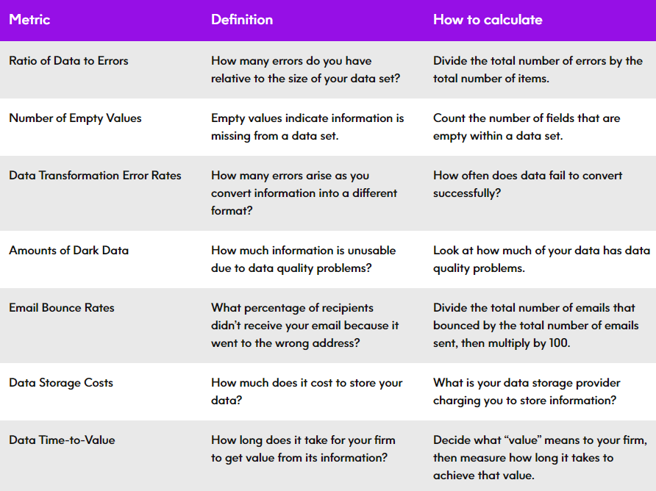

Image[Link](https://www.precisely.com/blog/data-quality/how-to-measure-data-quality-7-metrics)

<https://youtu.be/FG0ERPddcsg>

**Further reading / extension activity**

**Data governance report -**Use this [link](https://tdwi.org/research/2020/12/diq-all-best-practices-report-modern-data-governance.aspx?tc=page0)to download it (it is free)

**Aggregate functions with T-SQL**  
<https://youtu.be/fsLjuhQ5Ddw>